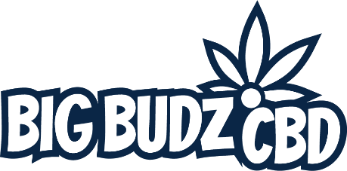

**2023**

**Product Catalog**

Premium Quality CBD & Hemp Products

Order Online at [www.bigbudzcbd.com](http://www.bigbudzcbd.com) or

call us at 269-932-8624

*Contact – customerservice@bigbudzcbd.com – with any questions*

All products are hemp derived, and contain less than 0.3% delta-9 THC, in full compliance with the 2018 Farm Bill

WHY CHOOSE US?

We take pride in only providing premium quality hemp derived CBD & hemp products! Our products are more potent and cleaner than the others! You will not get anything less than excellent from us. Our aim is repeat business. We are not satisfied unless you are! Buy CBD online from Big Budz CBD and enjoy the added customer traffic and increased profits to your retail location! Our business is designed around our buyers’ success!

OUR SPECIALITY

We specialize in retail ready CBD & Hemp products for retailers. We provide many types of retailers with competitively priced, premium quality products. **Savings and profits increase the more you order**. We serve gas stations, convenience stores, vape shops, glass shops, tobacco stores, CBD stores, hardware stores, hair salons, dispensaries, online retailers, and many others.**Increase customer traffic and save big by adding our products to your inventory today!**

CBD PRODUCTS

We provide the highest quality CBD products in the United States, all manufactured here is America. Buy CBD online from Big Budz CBD for more potent and cleaner CBD products than our competitors. Buying CBD online is a great way to avoid waiting on local distributors to restock your business. This way you can restock your CBD products as soon as you need to, and keep the sales flowing. Buy CBD products online from us on our easy to navigate website which offers additional benefits to brick and mortar locations such as free door signs and countertop displays to further drive sales of your highly profitable products from Big Budz CBD.

HEMP PRODUCTS

Let your customers enjoy the great benefits of our full spectrum hemp products and other popular hemp products such as HHC, THC-O, and Delta-10. All of these hemp products for sale are very popular among users that want a “high” from legal hemp derived products. Purchase our hemp products online on our website for cleaner and more potent product than our competitors. Big Budz CBD ensures the most premium quality products. We do not settle for less than the best for our buyers. Buy hemp products online from Big Budz CBD and receive additional benefits such as free door signs and countertop displays with your orders.

*A* weather proof *Door sign is included for retailers, on any order quantity!*

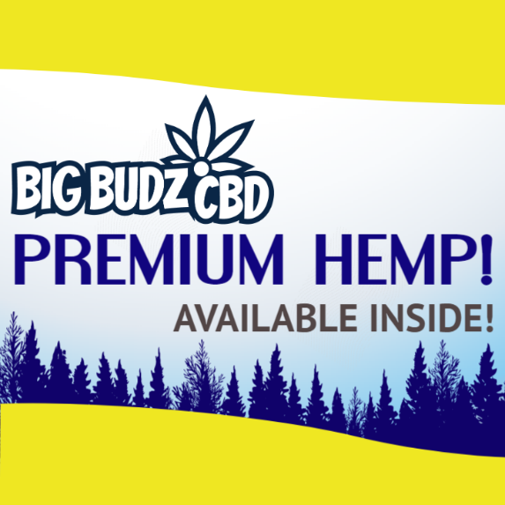

*Many business owners are increasing customer traffic and profits by adding Big Budz CBD to their stores!*

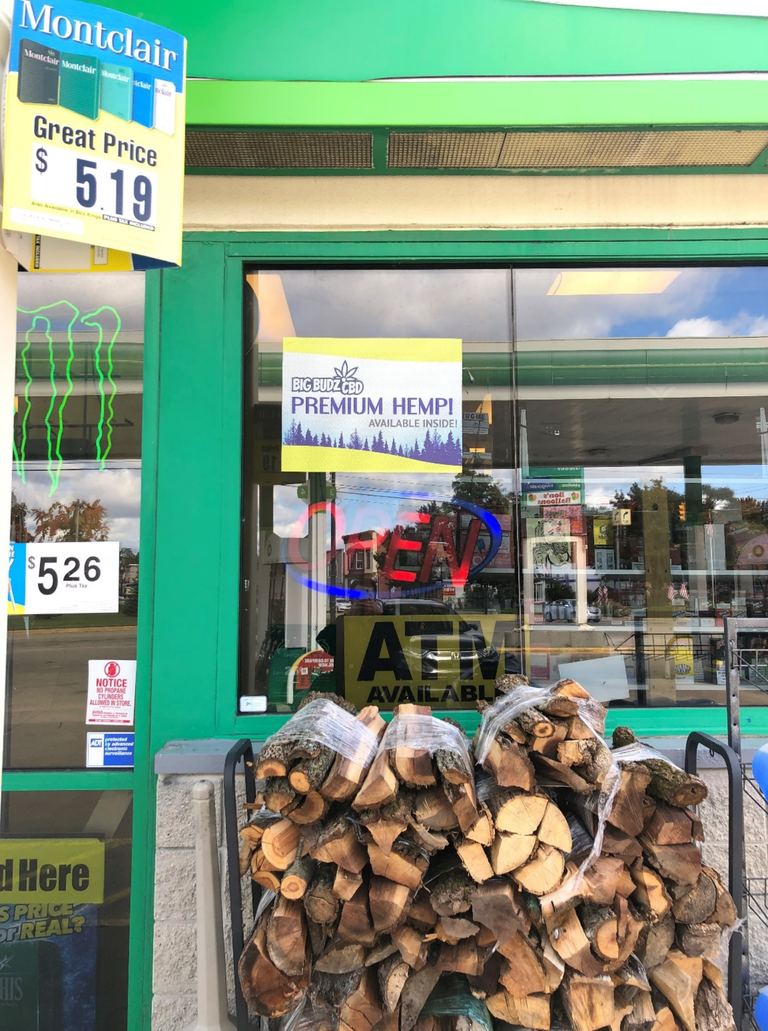

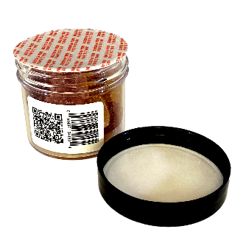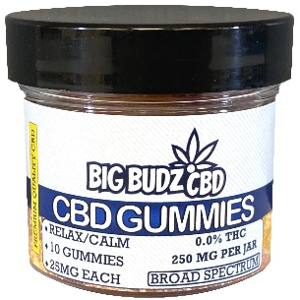

**10 CBD Gummies – 25mg Each – Broad Spectrum!**

Lemon, Orange, Watermelon, and Cherry flavored 25mg Broad Spectrum CBD Gummies! Better tasting CBD gummies that are strong and effective every time! Packaged into 10 count, 2oz Jars, perfect for providing CBD Gummies at a low price point for you customers!

25mg CBD, 0mg THC – Per Gummy!

*A free weather proof door sign will be provided for you at checkout!*

|  |  |  |  |
| --- | --- | --- | --- |
| Quantity/Price | Retail value | Profit - $ | MSRP per unit |
|  |  |  |  |
| 5 - $55.96 | $99.99 | $44 | $19.99 |
| 10 - $111.93 | $199.90 | $87.97 | $19.99 |
| 20 - $223.86 | $399.80 | $175.94 | $19.99 |
| 30 - $335.79 | $599.70 | $263.91 | $19.99 |
| 40 - $415.74 | $799.60 | $383.86 | $19.99 |
| 50 - $519.67 | $999.50 | $480 | $19.99 |
| 60 - $575.64 | $1,199.40 | $623.76 | $19.99 |
| 70 - $671.58 | $1,399.30 | $727.72 | $19.99 |
| 80 - $767.52 | $1,599.20 | $831.68 | $19.99 |
| 90 - $863.46 | $1,799.10 | $935.64 | $19.99 |
| 100- $959.40 | $1,999 | $1,039.60 | $19.99 |

****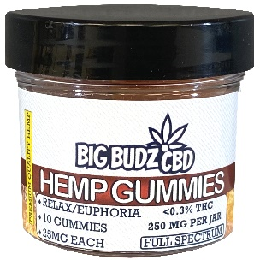

**10 CBD Gummies – 25mg Each – Full Spectrum!**

Lemon, Orange, Watermelon, and Cherry flavored 25mg Full Spectrum Hemp Gummies! Better tasting Hemp gummies that are strong and effective every time! Packaged into 10 count, 2oz Jars, perfect for providing Hemp gummies at a low price point for your customers!

20mg CBD, 5mg THC – Per gummy

*A free weather proof door sign will be provided for you at checkout!*

|  |  |  |  |
| --- | --- | --- | --- |
| Quantity/Price | Retail value | Profit - $ | MSRP per unit |
|  |  |  |  |
| 5 - $47.56 | $84.99 | $38 | $16.99 |
| 10 - $95.13 | $169.90 | $74.77 | $16.99 |
| 20 - $190.26 | $339.80 | $149.54 | $16.99 |
| 30 - $285.39 | $509.70 | $224.31 | $16.99 |
| 40 - $353.34 | $679.60 | $326.26 | $16.99 |
| 50 - $441.67 | $849.50 | $407.83 | $16.99 |
| 60 - $489.24 | $1,019.40 | $530.16 | $16.99 |
| 70 - $570.78 | $1,189.30 | $618.52 | $16.99 |
| 80 - $652.32 | $1,359.20 | $706.88 | $16.99 |
| 90 - $733.86 | $1,529.10 | $795.24 | $16.99 |
| 100- $815.40 | $1,699 | $883.60 | $16.99 |

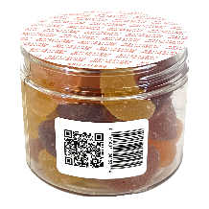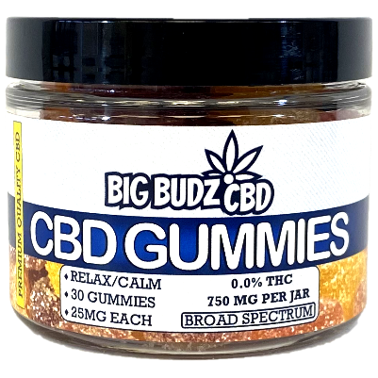

Lemon, Orange, Watermelon, and Cherry flavored 25mg Broad Spectrum CBD Gummies! Better tasting CBD gummies that are strong and effective every time! Packaged into 30 count Jars, perfect for a one month supply!

25mg CBD, 0mg THC - Per Gummy!

*A free weather proof door sign will be provided for you at checkout!*

**30 CBD Gummies – 25mg Each – Broad Spectrum!**

|  |  |  |  |
| --- | --- | --- | --- |
| Quantity/Price | Retail value | Profit - $ | MSRP per unit |
|  |  |  |  |
| 5 - $139.96 | $249.95 | $109.99 | $49.99 |
| 10 - $259.93 | $499.90 | $239.97 | $49.99 |
| 20 - $479.88 | $999.80 | $519.92 | $49.99 |
| 30 - $719.82 | $1,499.70 | $779.88 | $49.99 |
| 40 - $959.76 | $1,999.60 | $1,039.84 | $49.99 |
| 50 - $1,199.7 | $2,499.50 | $1,299.80 | $49.99 |
| 60 - $1,439.64 | $2,999.40 | $1,559.76 | $49.99 |
| 70 - $1,679.58 | $3,499.30 | $1,819.72 | $49.99 |
| 80 - $1,919.52 | $3,999.20 | $2,079.68 | $49.99 |
| 90 - $2,159.46 | $4,499.10 | $2,339.64 | $49.99 |
| 100 - $2,399.40 | $4,999 | $2,599.60 | $49.99 |

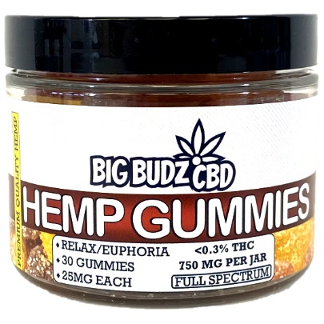

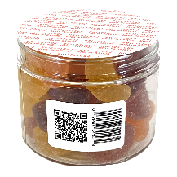

**30 CBD Gummies – 25mg Each – Full Spectrum!**

Lemon, Orange, Watermelon, and Cherry flavored 25mg Full Spectrum Hemp Gummies! Better tasting Hemp gummies that are strong and effective every time! Packaged into 30 count Jars, perfect for a one month supply!

20mg CBD, 5mg THC - Per Gummy!

*A free weather proof door sign will be provided for you at checkout!*

|  |  |  |  |
| --- | --- | --- | --- |
| Quantity/Price | Retail value | Profit - $ | MSRP per unit |
|  |  |  |  |
| 5 - $136.46 | $244.95 | $108.49 | $48.99 |
| 10 - $253.43 | $489.90 | $236.47 | $48.99 |
| 20 - $467.88 | $979.80 | $511.92 | $48.99 |
| 30 - $701.82 | $1,469.70 | $767.88 | $48.99 |
| 40 - $935.76 | $1,959.60 | $1,023.84 | $48.99 |
| 50 - $1,169.70 | $2,449.50 | $1,279.80 | $48.99 |
| 60 - $1,403.64 | $2,939.40 | $1,535.76 | $48.99 |
| 70 - $1,637.58 | $3,429.30 | $1,791.72 | $48.99 |
| 80 - $1,871.52 | $3,919.20 | $2,047.68 | $48.99 |
| 90 - $2,105.46 | $4,409.10 | $2,303.64 | $48.99 |
| 100 - $2,339.40 | $4,899 | $2,559.60 | $48.99 |

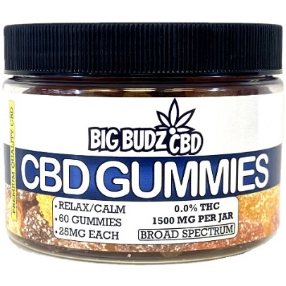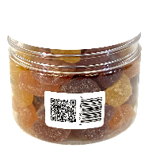

**60 CBD Gummies – 25mg Each – Broad Spectrum!**

Lemon, Orange, Watermelon, and Cherry flavored 25mg Broad Spectrum CBD Gummies! Better tasting CBD gummies that are strong and effective every time! Packaged into 60 count Jars, perfect for a two month supply!

25mg CBD, 0mg THC - Per Gummy!

*A free weather proof door sign will be provided for you at checkout!*

|  |  |  |  |
| --- | --- | --- | --- |
| Quantity/Price | Retail value | Profit - $ | MSRP per unit |
|  |  |  |  |
| 5 - $209.96 | $374.95 | $164.99 | $74.99 |
| 10 - $389.93 | $749.90 | $359.97 | $74.99 |
| 20 - $719.88 | $1,499.80 | $779.92 | $74.99 |
| 30 - $1,079.82 | $2,249.70 | $1,169.88 | $74.99 |
| 40 - $1,439.76 | $2,999.60 | $1,559.84 | $74.99 |
| 50 - $1,799.70 | $3,749.50 | $1,949.80 | $74.99 |
| 60 - $2,159.64 | $4,499.40 | $2,339.76 | $74.99 |
| 70 - $2,519.58 | $5,249.30 | $2,729.72 | $74.99 |
| 80 - $2,879.52 | $5,999.20 | $3,119.68 | $74.99 |
| 90 - $3,239.46 | $6,749.10 | $3,509.64 | $74.99 |
| 100 -$3,599.40 | $7,499 | $3,899.60 | $74.99 |

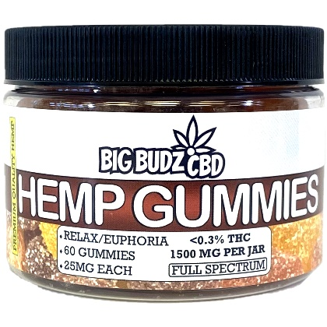

**60 CBD Gummies – 25mg Each – Full Spectrum!**



Lemon, Orange, Watermelon, and Cherry flavored 25mg Full Spectrum Hemp Gummies! Better tasting Hemp gummies that are strong and effective every time! Packaged into 60 count Jars, perfect for a two month supply!

20mg CBD, 5mg THC - Per Gummy!

*A free weather proof door sign will be provided for you at checkout!*

|  |  |  |  |
| --- | --- | --- | --- |
| Quantity/Price | Retail value | Profit - $ | MSRP per unit |
|  |  |  |  |
| 5 - $209.96 | $374.95 | $164.99 | $74.99 |
| 10 - $389.93 | $749.90 | $359.97 | $74.99 |
| 20 - $719.88 | $1,499.80 | $779.92 | $74.99 |
| 30 - $1,079.82 | $2,249.70 | $1,169.88 | $74.99 |
| 40 - $1,439.76 | $2,999.60 | $1,559.84 | $74.99 |
| 50 - $1,799.70 | $3,749.50 | $1,949.80 | $74.99 |
| 60 - $2,159.64 | $4,499.40 | $2,339.76 | $74.99 |
| 70 - $2,519.58 | $5,249.30 | $2,729.72 | $74.99 |
| 80 - $2,879.52 | $5,999.20 | $3,119.68 | $74.99 |
| 90 - $3,239.46 | $6,749.10 | $3,509.64 | $74.99 |
| 100 -$3,599.40 | $7,499 | $3,899.60 | $74.99 |

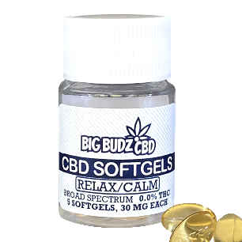

Broad Spectrum 30mg CBD Softgels! The strongest and most effective every time! Packaged into 10 count bottles, perfect for providing CBD softgels at a low price point for you customers! A sugar free way for your customers to quickly incorporate Broad Spectrum CBD oil into their routine!

30mg CBD, 0mg THC – Per Softgel!

*A free weather proof door sign will be provided for you at checkout!*

**5 CBD Softgels – 30mg Each – Broad Spectrum**

|  |  |  |  |
| --- | --- | --- | --- |
| Quantity/Price | Retail value | Profit - $ | MSRP per unit |
|  |  |  |  |
| 5 - $44.99 | $64.99 | $20 | $12.99 |
| 10 - $90.50 | $129.90 | $39.40 | $12.99 |
| 20 - $181.50 | $259.80 | $78.30 | $12.99 |
| 30 - $272.50 | $389.70 | $117.20 | $12.99 |
| 40 - $363.50 | $519.60 | $156.10 | $12.99 |
| 50 - $454.50 | $649.50 | $195 | $12.99 |
| 60 - $506.50 | $779.40 | $272.90 | $12.99 |
| 70 - $590.99 | $909.30 | $318.31 | $12.99 |
| 80 - $674.99 | $1,039.20 | $364.21 | $12.99 |
| 90 - $759.50 | $1,169.1 | $409.60 | $12.99 |
| 100- $778.99 | $1,299 | $520.01 | $12.99 |
| 150 - $1,168.99 | $1,948.50 | $779.51 | $12.99 |
| 200 - $1,558.50 | $2,598 | $1,039.50 | $12.99 |

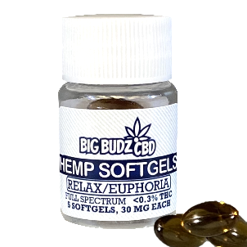

Full Spectrum 30mg Hemp Softgels! The strongest and most effective every time! Packaged into 10 count bottles, perfect for providing Hemp softgels at a low price point for you customers! A sugar free way for your customers to quickly incorporate Full Spectrum Hemp oil into their routine!

30mg CBD, 1mg THC – Per Softgel!

*A free weather proof door sign will be provided for you at checkout!*

**5 CBD Softgels – 30mg Each – Full Spectrum**

|  |  |  |  |
| --- | --- | --- | --- |
| Quantity/Price | Retail value | Profit - $ | MSRP per unit |
|  |  |  |  |
| 5 - $44.99 | $64.99 | $20 | $12.99 |
| 10 - $90.50 | $129.90 | $39.40 | $12.99 |
| 20 - $181.50 | $259.80 | $78.30 | $12.99 |
| 30 - $272.50 | $389.70 | $117.20 | $12.99 |
| 40 - $363.50 | $519.60 | $156.10 | $12.99 |
| 50 - $454.50 | $649.50 | $195 | $12.99 |
| 60 - $506.50 | $779.40 | $272.90 | $12.99 |
| 70 - $590.99 | $909.30 | $318.31 | $12.99 |
| 80 - $674.99 | $1,039.20 | $364.21 | $12.99 |
| 90 - $759.50 | $1,169.1 | $409.60 | $12.99 |
| 100- $778.99 | $1,299 | $520.01 | $12.99 |
| 150 - $1,168.99 | $1,948.50 | $779.51 | $12.99 |
| 200 - $1,558.50 | $2,598 | $1,039.50 | $12.99 |

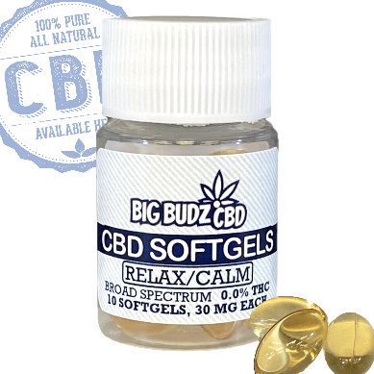

Broad Spectrum 30mg CBD Softgels! The strongest and most effective every time! Packaged into 10 count bottles, perfect for providing CBD softgels at a low price point for you customers! A sugar free way for your customers to quickly incorporate Broad Spectrum CBD oil into their routine!

30mg CBD, 0mg THC – Per Softgel!

*A free weather proof door sign will be provided for you at checkout!*

**10 CBD Softgels – 30mg Each – Broad Spectrum**

|  |  |  |  |
| --- | --- | --- | --- |
| Quantity/Price | Retail value | Profit - $ | MSRP per unit |
|  |  |  |  |
| 5 - $69.96 | $124.99 | $55 | $24.99 |
| 10 - $139.93 | $249.90 | $109.97 | $24.99 |
| 20 - $279.86 | $499.80 | $219.94 | $24.99 |
| 30 - $389.80 | $749.70 | $359.90 | $24.99 |
| 40 - $479.76 | $999.60 | $519.84 | $24.99 |
| 50 - $599.70 | $1,249.50 | $650 | $24.99 |
| 60 - $719.64 | $1,499.40 | $779.76 | $24.99 |
| 70 - $839.58 | $1,749.30 | $909.72 | $24.99 |
| 80 - $959.52 | $1,999.20 | $1,039.68 | $24.99 |
| 90 - $1,079.46 | $2,249.10 | $1,169.64 | $24.99 |
| 100- $1,199.40 | $2,499 | $1,299.60 | $24.99 |

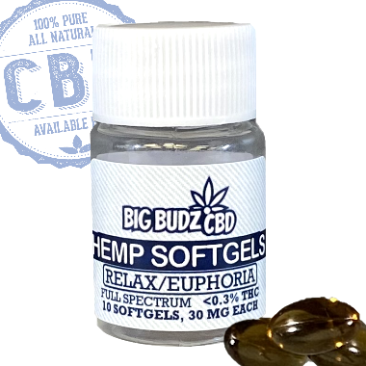

Full Spectrum 30mg Hemp Softgels! The strongest and most effective every time! Packaged into 10 count bottles, perfect for providing Hemp softgels at a low price point for you customers! A sugar free way for your customers to quickly incorporate Full Spectrum Hemp oil into their routine!

30mg CBD, 1mg THC – Per Softgel!

*A free weather proof door sign will be provided for you at checkout!*

**10 CBD Softgels – 30mg Each – Full Spectrum**

|  |  |  |  |
| --- | --- | --- | --- |
| Quantity/Price | Retail value | Profit - $ | MSRP per unit |
|  |  |  |  |
| 5 - $69.96 | $124.99 | $55 | $24.99 |
| 10 - $139.93 | $249.90 | $109.97 | $24.99 |
| 20 - $279.86 | $499.80 | $219.94 | $24.99 |
| 30 - $389.80 | $749.70 | $359.90 | $24.99 |
| 40 - $479.76 | $999.60 | $519.84 | $24.99 |
| 50 - $599.70 | $1,249.50 | $650 | $24.99 |
| 60 - $719.64 | $1,499.40 | $779.76 | $24.99 |
| 70 - $839.58 | $1,749.30 | $909.72 | $24.99 |
| 80 - $959.52 | $1,999.20 | $1,039.68 | $24.99 |
| 90 - $1,079.46 | $2,249.10 | $1,169.64 | $24.99 |
| 100- $1,199.40 | $2,499 | $1,299.60 | $24.99 |

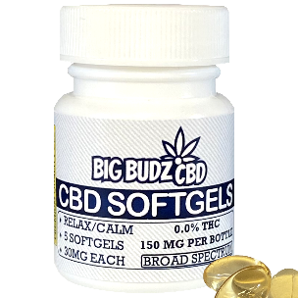

Broad Spectrum 30mg CBD Softgels! The strongest and most effective every time! Packaged into 5 count bottles, perfect for providing CBD softgels at a low price point for you customers! A sugar free way for your customers to quickly incorporate Broad Spectrum CBD oil into their routine!

30mg CBD, 0mg THC – Per Softgel!

*A free weather proof door sign will be provided for you at checkout!*

**5 CBD Softgels – 30mg Each – Broad Spectrum!**

|  |  |  |  |
| --- | --- | --- | --- |
| Quantity/Price | Retail value | Profit - $ | MSRP per unit |
|  |  |  |  |
| 5 - $44.99 | $64.99 | $20 | $12.99 |
| 10 - $90.50 | $129.90 | $39.40 | $12.99 |
| 20 - $181.50 | $259.80 | $78.30 | $12.99 |
| 30 - $272.50 | $389.70 | $117.20 | $12.99 |
| 40 - $363.50 | $519.60 | $156.10 | $12.99 |
| 50 - $454.50 | $649.50 | $195 | $12.99 |
| 60 - $506.50 | $779.40 | $272.90 | $12.99 |
| 70 - $590.99 | $909.30 | $318.31 | $12.99 |
| 80 - $674.99 | $1,039.20 | $364.21 | $12.99 |
| 90 - $759.50 | $1,169.1 | $409.60 | $12.99 |
| 100- $778.99 | $1,299 | $520.01 | $12.99 |
| 150 - $1,168.99 | $1,948.50 | $779.51 | $12.99 |
| 200 - $1,558.50 | $2,598 | $1,039.50 | $12.99 |

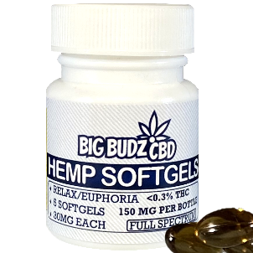

Full Spectrum 30mg Hemp Softgels! The strongest and most effective every time! Packaged into 5 count bottles, perfect for providing Hemp softgels at a low price point for you customers! A sugar free way for your customers to quickly incorporate Full Spectrum Hemp oil into their routine!

30mg CBD, 1mg THC – Per Softgel!

*A free weather proof door sign will be provided for you at checkout!*

**5 CBD Softgels – 30mg Each – Full Spectrum!**

|  |  |  |  |
| --- | --- | --- | --- |
| Quantity/Price | Retail value | Profit - $ | MSRP per unit |
|  |  |  |  |
| 5 - $44.99 | $64.99 | $20 | $12.99 |
| 10 - $90.50 | $129.90 | $39.40 | $12.99 |
| 20 - $181.50 | $259.80 | $78.30 | $12.99 |
| 30 - $272.50 | $389.70 | $117.20 | $12.99 |
| 40 - $363.50 | $519.60 | $156.10 | $12.99 |
| 50 - $454.50 | $649.50 | $195 | $12.99 |
| 60 - $506.50 | $779.40 | $272.90 | $12.99 |
| 70 - $590.99 | $909.30 | $318.31 | $12.99 |
| 80 - $674.99 | $1,039.20 | $364.21 | $12.99 |
| 90 - $759.50 | $1,169.1 | $409.60 | $12.99 |
| 100- $778.99 | $1,299 | $520.01 | $12.99 |
| 150 - $1,168.99 | $1,948.50 | $779.51 | $12.99 |
| 200 - $1,558.50 | $2,598 | $1,039.50 | $12.99 |

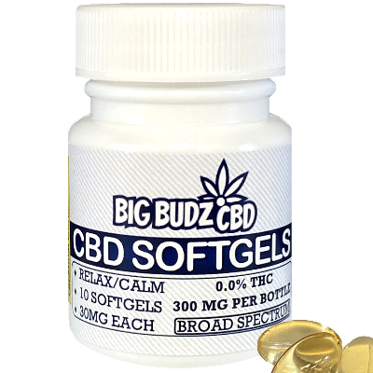

Broad Spectrum 30mg CBD Softgels! The strongest and most effective every time! Packaged into 10 count bottles, perfect for providing CBD softgels at a low price point for your customers! A sugar free way for your customers to quickly incorporate Broad Spectrum CBD oil into their routine!

30mg CBD, 0mg THC – Per softgel!

*A free weather proof door sign will be provided for you at checkout!*

**10 CBD Softgels – 30mg Each – Broad Spectrum!**

|  |  |  |  |
| --- | --- | --- | --- |
| Quantity/Price | Retail value | Profit - $ | MSRP per unit |
|  |  |  |  |
| 5 - $69.96 | $124.99 | $55 | $24.99 |
| 10 - $139.93 | $249.90 | $109.97 | $24.99 |
| 20 - $279.86 | $499.80 | $219.94 | $24.99 |
| 30 - $389.80 | $749.70 | $359.90 | $24.99 |
| 40 - $479.76 | $999.60 | $519.84 | $24.99 |
| 50 - $599.70 | $1,249.50 | $650 | $24.99 |
| 60 - $719.64 | $1,499.40 | $779.76 | $24.99 |
| 70 - $839.58 | $1,749.30 | $909.72 | $24.99 |
| 80 - $959.52 | $1,999.20 | $1,039.68 | $24.99 |
| 90 - $1,079.46 | $2,249.10 | $1,169.64 | $24.99 |
| 100- $1,199.40 | $2,499 | $1,299.60 | $24.99 |

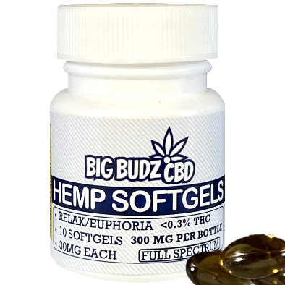

Full Spectrum 30mg Hemp Softgels! The strongest and most effective every time! Packaged into 10 count bottles, perfect for providing Hemp softgels at a low price point for you customers! A sugar free way for your customers to quickly incorporate Full Spectrum Hemp oil into their routine!

30mg CBD, 1mg THC – Per Softgel!

*A free weather proof door sign will be provided for you at checkout!*

**10 CBD Softgels – 30mg Each – Full Spectrum!**

|  |  |  |  |
| --- | --- | --- | --- |
| Quantity/Price | Retail value | Profit - $ | MSRP per unit |
|  |  |  |  |
| 5 - $69.96 | $124.99 | $55 | $24.99 |
| 10 - $139.93 | $249.90 | $109.97 | $24.99 |
| 20 - $279.86 | $499.80 | $219.94 | $24.99 |
| 30 - $389.80 | $749.70 | $359.90 | $24.99 |
| 40 - $479.76 | $999.60 | $519.84 | $24.99 |
| 50 - $599.70 | $1,249.50 | $650 | $24.99 |
| 60 - $719.64 | $1,499.40 | $779.76 | $24.99 |
| 70 - $839.58 | $1,749.30 | $909.72 | $24.99 |
| 80 - $959.52 | $1,999.20 | $1,039.68 | $24.99 |
| 90 - $1,079.46 | $2,249.10 | $1,169.64 | $24.99 |
| 100- $1,199.40 | $2,499 | $1,299.60 | $24.99 |

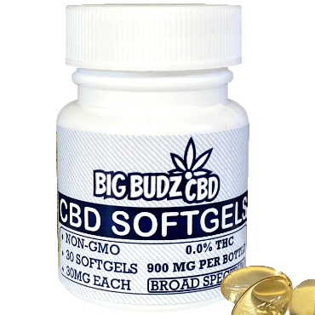

Broad Spectrum 30mg CBD Softgels! The strongest and most effective every time! Packaged into 30 count bottles, perfect for a one month supply! A sugar free way to quickly incorporate Broad Spectrum CBD oil into your routine!

30mg CBD, 0mg THC – Per Softgel!

*A free weather proof door sign will be provided for you at checkout!*

**30 CBD Softgels – 30mg Each – Broad Spectrum!**

|  |  |  |  |
| --- | --- | --- | --- |
| Quantity/Price | Retail value | Profit - $ | MSRP per unit |
|  |  |  |  |
| 5 - $204.36 | $364.95 | $160.59 | $72.99 |
| 10 - $379.53 | $729.90 | $350.37 | $72.99 |
| 20 - $700.68 | $1,459.80 | $759.12 | $72.99 |
| 30 -$1,051.02 | $2,189.70 | $1,138.68 | $72.99 |
| 40 - $1,401.36 | $2,919.60 | $1,518.24 | $72.99 |
| 50 - $1,751.70 | $3,649.50 | $1,897.80 | $72.99 |
| 60 - $2,102.04 | $4,379.40 | $2,277.36 | $72.99 |
| 70 - $2,452.38 | $5,109.30 | $2,656.92 | $72.99 |
| 80 - $2,802.72 | $5,839.20 | $3,036.48 | $72.99 |
| 90 - $3,153.06 | $6,569.10 | $3,416.04 | $72.99 |
| 100 - $3,503.40 | $7,299 | $3,795.60 | $72.99 |

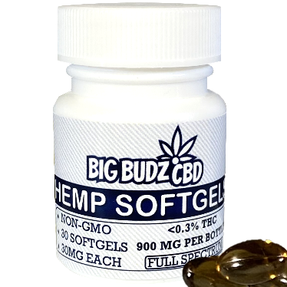

**30 CBD Softgels – 30mg Each – Full Spectrum!**

Full Spectrum 30mg Hemp Softgels! The strongest and most effective every time! Packaged into 30 count bottles, perfect for a one month supply! A sugar free way to quickly incorporate Full Spectrum Hemp oil into your routine!

30mg CBD, 1mg THC – Per Softgel!

*A free weather proof door sign will be provided for you at checkout!*

|  |  |  |  |
| --- | --- | --- | --- |
| Quantity/Price | Retail value | Profit - $ | MSRP per unit |
|  |  |  |  |
| 5 - $204.36 | $364.95 | $160.59 | $72.99 |
| 10 - $379.53 | $729.90 | $350.37 | $72.99 |
| 20 - $700.68 | $1,459.80 | $759.12 | $72.99 |
| 30 -$1,051.02 | $2,189.70 | $1,138.68 | $72.99 |
| 40 - $1,401.36 | $2,919.60 | $1,518.24 | $72.99 |
| 50 - $1,751.70 | $3,649.50 | $1,897.80 | $72.99 |
| 60 - $2,102.04 | $4,379.40 | $2,277.36 | $72.99 |
| 70 - $2,452.38 | $5,109.30 | $2,656.92 | $72.99 |
| 80 - $2,802.72 | $5,839.20 | $3,036.48 | $72.99 |
| 90 - $3,153.06 | $6,569.10 | $3,416.04 | $72.99 |
| 100 - $3,503.40 | $7,299 | $3,795.60 | $72.99 |

**Trial pack – 10 CBD Gummy Jars – Broad Spectrum & Full Spectrum:**

Contents of trial pack:

* 10-count, 25mg gummies, broad spectrum, 2oz Jar (X2)

(MSRP per unit = $19.99)

* 10-count, 25mg gummies, full spectrum, 2oz Jar (X2)

(MSRP per unit = $16.99)

Assorted flavor 25mg full spectrum & broad spectrum gummies. This trial pack includes a combination of full spectrum & broad spectrum gummies, packaged in 10 count 2oz Jars.

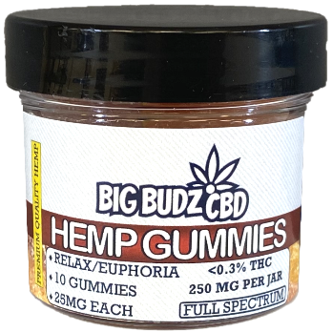**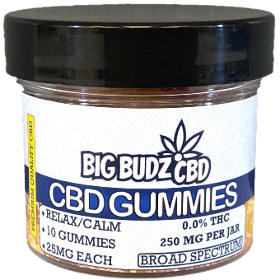***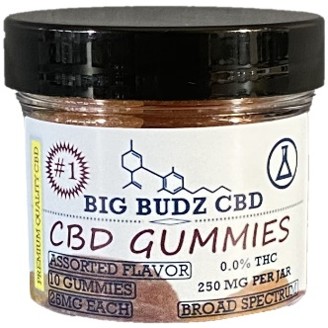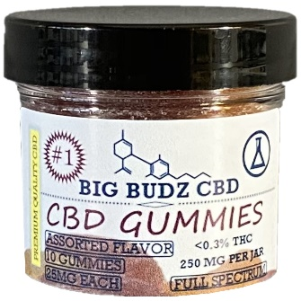*

*Low price of $62!*

**Trial pack – 5 CBD Softgel Mini Bottles – Broad Spectrum & Full Spectrum:**

Contents of trial pack:

* 5-count, 30mg softgels, broad spectrum, 15ml clear bottle (X2)

(MSRP per unit = $12.99)

* 5-count, 30mg softgels, full spectrum, 15ml clear bottle (X2)

(MSRP per unit = $12.99)

 30mg broad spectrum & full spectrum softgels. This trial pack includes a combination of broad spectrum & full spectrum softgels, packaged in 5-count, 15ml clear bottles.

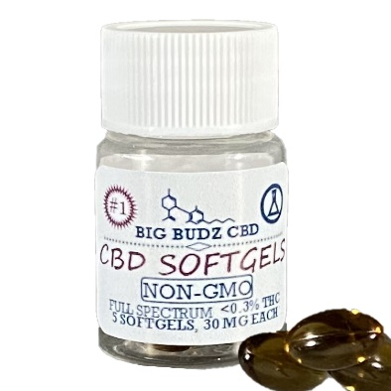

*Low price of $43.50!*

**Trial pack – 5 CBD Softgel Mini Bottles – Broad Spectrum & Full Spectrum!**

Contents of trial pack:

* 5-count, 30mg softgels, broad spectrum, 30ml white bottle (X2)

(MSRP per unit = $12.99)

* 5-count, 30mg softgels, full spectrum, 30ml white bottle (X2)

(MSRP per unit = $12.99)

 30mg broad spectrum & full spectrum softgels. This trial pack includes a combination of broad spectrum & full spectrum softgels, packaged in 5-count, 30ml white bottles.

*****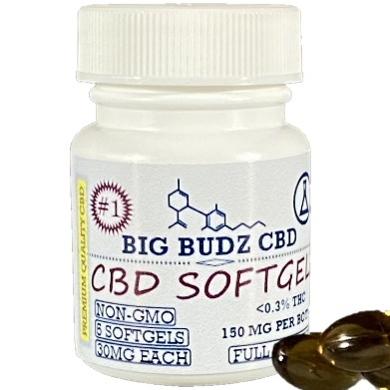*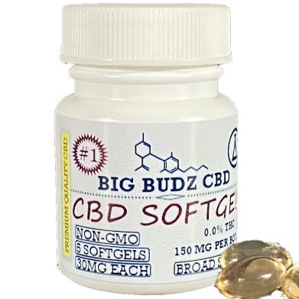

*Low price of $43.50!*

**Trial pack – 10 CBD Softgel Mini Bottles – Broad Spectrum & Full Spectrum:**

Contents of trial pack:

* 10-count, 30mg softgels, broad spectrum, 15ml clear bottle (X2)

(MSRP per unit = $24.99)

* 10-count, 30mg softgels, full spectrum, 15ml clear bottle (X2)

(MSRP per unit = $24.99)

30mg broad spectrum & full spectrum softgels. This trial pack includes a combination of broad spectrum & full spectrum softgels, packaged in 10-count, 15ml clear bottles.

****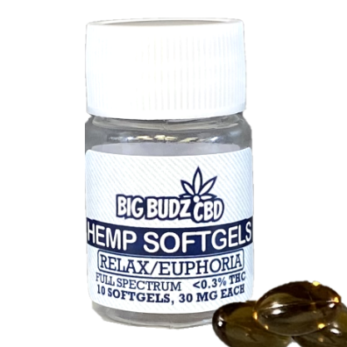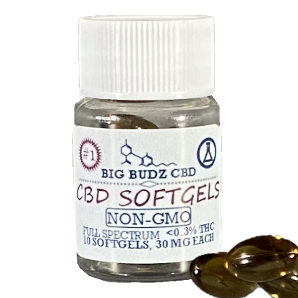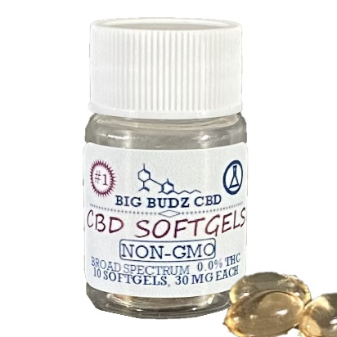

*Low price of $84.50!*

**Trial pack – 10 CBD Softgel Mini Bottles – Broad Spectrum & Full Spectrum!**

Contents of trial pack:

* 10-count, 30mg softgels, broad spectrum, 30ml white bottle (X2)

(MSRP per unit = $24.99)

* 10-count, 30mg softgels, full spectrum, 30ml white bottle (X2)

(MSRP per unit = $24.99)

30mg broad spectrum & full spectrum softgels. This trial pack includes a combination of broad spectrum & full spectrum softgels, packaged in 10-count, 30ml white bottles.

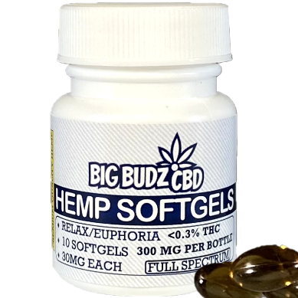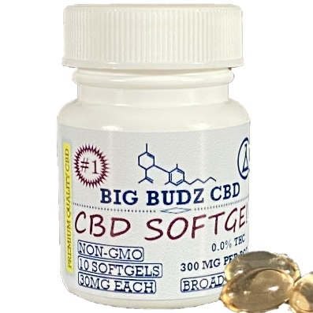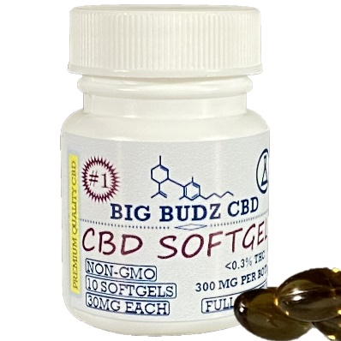

*Low price of $84.50!*

**Trial pack – 5 CBD Softgel Mini Bottles (2 Sizes) – Broad Spectrum & Full Spectrum:**

Contents of trial pack:

* 5-count, 30mg softgels, broad spectrum, 15ml clear bottle (X2)

(MSRP per unit = $12.99)

* 5-count, 30mg softgels, broad spectrum, 30ml white bottle (X2)

(MSRP per unit = $12.99)

* 5-count, 30mg softgels, full spectrum, 15ml clear bottle (X2)

(MSRP per unit = $12.99)

* 5-count, 30mg softgels, full spectrum, 30ml white bottle (X2)

(MSRP per unit = $12.99)

30mg broad spectrum & full spectrum softgels. This trial pack includes a combination of broad spectrum & full spectrum softgels, packaged in 5-count, 15ml clear bottles & 5-count, 30ml white bottles.

*********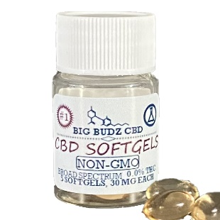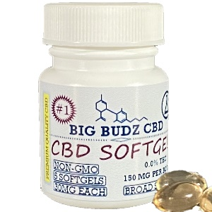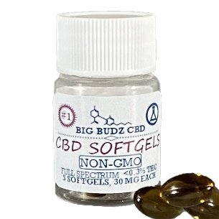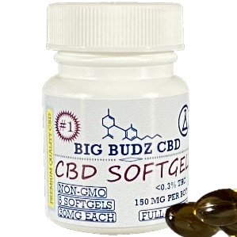*

*Low price of $87.50!*

**Trial pack – 10 CBD Softgel Mini Bottles (2 Sizes) – Broad Spectrum & Full Spectrum:**

Contents of trial pack:

* 10-count, 30mg softgels, broad spectrum, 15ml clear bottle (X2)

(MSRP per unit = $24.99)

* 10-count, 30mg softgels, broad spectrum, 30ml white bottle (X2)

(MSRP per unit = $24.99)

* 10-count, 30mg softgels, full spectrum, 15ml clear bottle (X2)

(MSRP per unit = $24.99)

* 10-count, 30mg softgels, full spectrum, 30ml white bottle (X2)

(MSRP per unit = $24.99)

30mg broad spectrum & full spectrum softgels. This trial pack includes a combination of broad spectrum & full spectrum softgels, packaged in 10-count 15ml clear bottles and 10-count 30ml white bottles.

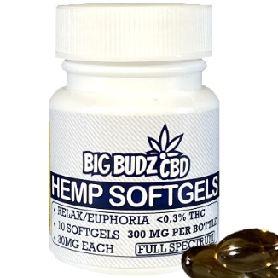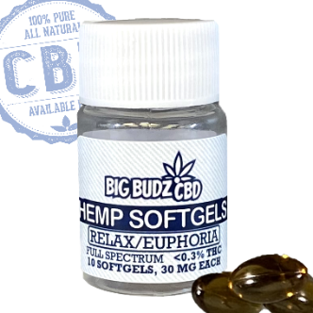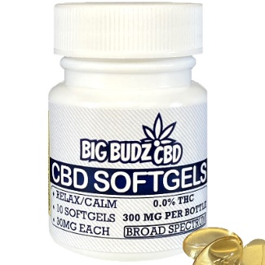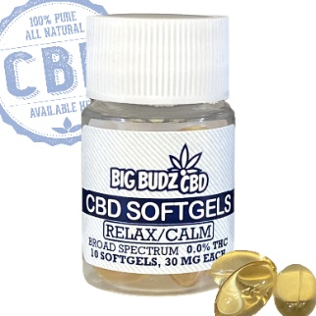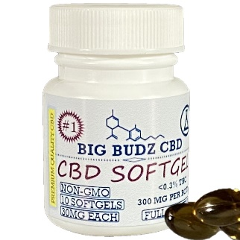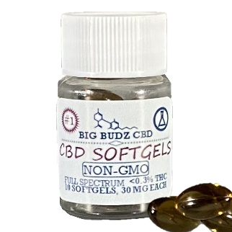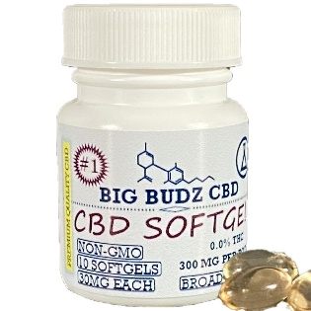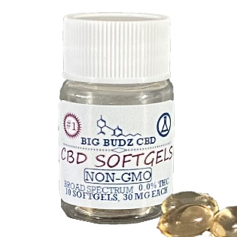

*Low price of $169.50!*